Milepost 3 Term 1 2021-2022

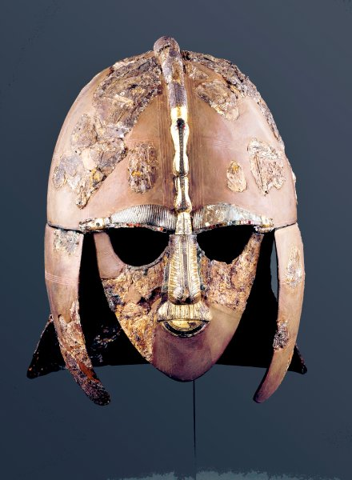

**THE GREAT, THE BOLD & THE BRAVE**

**Curriculum Newsletter**

Our focus this term will be upon investigating some of the different people who have affected our early British history, with their impact being felt in our lives right up to the present day. We will be focusing on the time period from 463BC up until 1066AD, studying the Celts, the Romans and the Anglo-Saxons. Through their learning this term, the children will be able to gain a real insight into our historical past with special focus on some of our local historical features, including a trip to the fabulous Corinium Museum in Cirencester to set the scene.

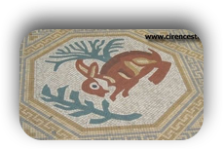

Maths

Consistent learning objectives across the Milepost this term will be: reading, writing, ordering and comparing increasingly large numbers and consolidating the children’s understanding of using mental and formal written methods of addition and subtraction. Additionally, the children in Year 6 will be consolidating their understanding of mental and formal written methods of multiplication and division.

DATES FOR THE DIARY

September

22nd Yr5/6 Football

Tournament

23rd Yr 6 Open Evening at Malmesbury Secondary school

30th Parents Information

Meeting for Morfa Bay

Residential

October

7th Parents Evening - 5:00 - 7:30pm

11th Year 5 Trip to the Corinium Museum

12th Parents Evening - 4:00 - 6:30pm

13th Yr 5/6 Tag Rugby Festival

15th Year 6 Trip to the Corinium Museum

19th Last Day of Term

November

1st First day of the new term

English

Year 5 will base their English work around the theme of myths. They will be writing a mythical story and will be writing an information report about the Romans.

Year 6, at present, are concentrating on narrative writing based on Myths and Legends and later in the term will be looking in more detail at information texts.

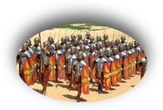

The more you know about the past, the better you are prepared for the future.

Milepost 3 Term 1 2021-2022

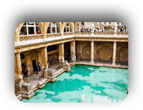

History

During this term, the children will be looking at how people lived in the past. We will be investigating: the Celts; the impact of the Roman Empire including the invasion of Britain and life as a Roman. Additionally, we will be investigating the settlement of Britain by the Anglo-Saxons and we will be creating a timeline from the Stone Age to Modern Day.

Art

The children will be researching Roman art such as pottery and mosaics and the children will be creating clay pots.

Religious Education

Year 5 will be looking at the People of God. They will consider how Christians believe they should behave, together with identifying ideas about freedom and justice. Also, they will investigate the connections between the story of Moses and the message of freedom for all people.

In Year 6, we will be exploring our own views of world religion in our theme of ‘Nobody Stands Nowhere’. In this unit we learn that people have different ideologies and encourage the children to respect each others viewpoints.

Learn 4 Life

In Year 5, the children will be considering issues related to friendships and we will also be focusing on the importance of internet safety.

In Year 6, the children will be learning about digital citizenship and how to stay safe online.

Computing

In Year 5, the children will be improving their coding skills through using our Lego We Do resources.

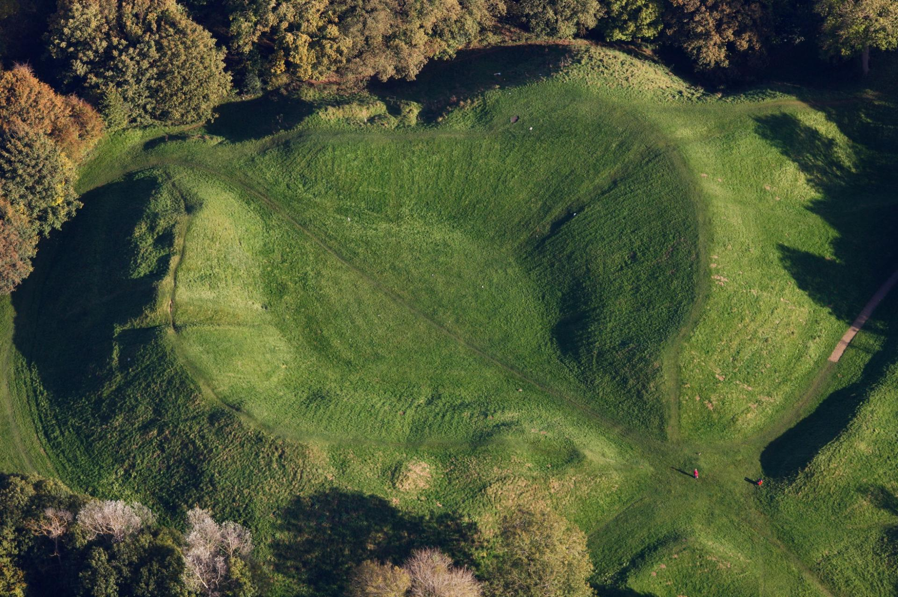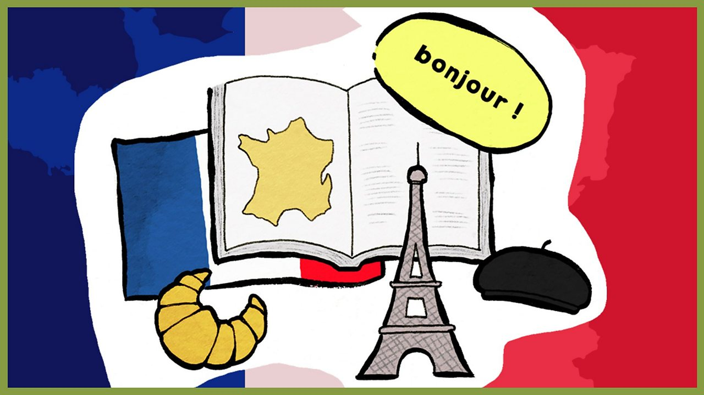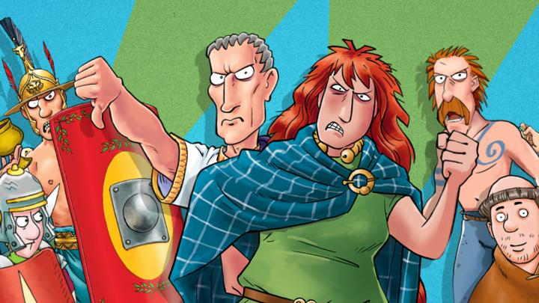

French

In Year 5, the children will be practising the days and months of the year and counting to 60 together with expanding their vocabulary to include colours and animals.

Don’t forget to check the school website [www.malmesburyprimaryschool.co.uk](http://www.malmesburyprimaryschool.co.uk) for up to date information.